

|  |
| --- |
| **Design Brief** |

**Project Title:**

**Client: Nicholas Paz and Brandon Alcala**

**Designer(s):Peter Zheng, Chris Hilario**

**Problem Statement:**

The problem we are facing are the murders in Los Angeles county. Murder is a serious problem that could affect anyone and if it does it is devastating. Murder is a problem that should always tried to be prevented or at least tried to be reduced at any cost. Therefore, we developed an idea to test if an income lower than around $50,000 affects the amount of murders in Los Angeles County. To find this out we will compare Los Angeles with San Francisco. In 2016, San Francisco had 25 murders whereas, Los Angeles had 136. We took into account that Los Angeles had 3,962,726 people living there and San Francisco had 86,782 people living there. San Francisco with 3,962,726 living there would cause approximately 115 murders. Obvious there are more factors that come into play than just population, but even when San Francisco matches the population of Los Angeles San Francisco still has a lower murder count. In the LA Times, writers Ben Poston and Kate Mather wrote, “Garcetti said he felt increased urgency in late March, when a daily crime report showed a 32.7% rise in killings across the city”. Murder is an urgent issue that people should always be trying to find a way to reduce. Perhaps income does affect the amount of murder that happens and if there is any chance it does affect it then it must be fixed.

2016. (2016, December 05). Retrieved February 01, 2017, from https://ucr.fbi.gov/crime-in-the-u.s/2016/preliminary-semiannual-uniform-crime-report-januaryjune-2016/tables/table-4/state-cuts/table_4_january_to_june_2016_offenses_reported_to_law_enforcement_by_state_alabama_through_california.xls

Poston, B., & Mather, K. (2016, July 22). Overall crime is up in L.A. for the second straight year, LAPD reports. Retrieved February 01, 2017, from [**http://www.latimes.com/local/california/la-me-lapd-crime-increase-20160722-snap-story.html**](http://www.latimes.com/local/california/la-me-lapd-crime-increase-20160722-snap-story.html)

**Design Statement:**

The problem with los angeles is that the crimes there are higher than other cities in California. Us helping the clients trying to find the rates of crimes committed in one of the largest city in the world would give a light to the problem. thanks to the clients already given information we have some foundation on what we can perform on the subject, sadly we need more information on the topic to perform an accurate pieces of data. for now we will work on the already given information to find the link between the rate of crimes and the amount of income the cities of californa have.To show this, we want to create a scatter plot to show the differences of income and crime between the cities. so we can compare the income in each city not just in california but in a couple of other states to see if the income affects the crime rate in each city.

**Constraints:**

* **low amounts of information**
* **time**
* **lack of material at home**
* **not enough time**

**conclusion**

The question that we had was does the amount of income a city reserves affect the amount of crime committed? What we have found is that between san francisco and los angeles the amount of crime and the amount of income is visible but compared to the other cities crime and income doesn't seem to have a connection. The first main city is Los Anglos with a low income rate compared to san francisco and one of the highest crime ratings in california, our theory of low income high crime rate seems to be true. Sadly with more factors applied like other cities our theory takes a nosedive. At this moment it can be seen like the link between crime and income is false but i must state that the other cities have a sufficiently smaller population than our main two cities Los Angeles and San Francisco. So population would have an affect on the amount of crime a city could have.

**Problem Statement Instructions:**

A Problem Statement should be a research-based statement describing why the particular experiment, project, or project should be funded / completed. The statement needs to include at least two sources with APA citations. The problem statement should be 150 – 250 words in length. See the example below.

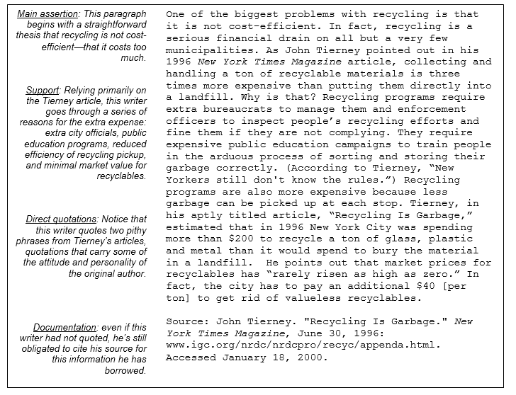

You may also want to use a counter-argument that preempts an opponent’s response to your persuasion.

**Design / Concept Statement Instructions:**

A Design Statement is a brief description by an inventive person about their creative process—and the work they produce. Drafting a statement helps the designer focus on their inspirations and style, as well as providing insight into their perspective on the world for others to appreciate. Every piece of work that a designer creates can be considered in relation to such a statement—is it in alignment with the designer’s philosophy, does it break new ground, or is it in conflict with the designer’s goals and style? The statement should be 150 – 250 words.

*A few questions to ask yourself before writing a Designer’s Statement:*

* What do you want to say as a designer?
* What kind of impact would you like to make?
* What is your style?
* What are your inspirations?
* What is the concept behind your design: color, philosophy, layout?
* Can you talk about/write about your approach to Art? Design? Life?
* What are you resistant to in terms of design?

An example can be seen below:



**Constraints Instructions:**

Constraints are the rules you must following when completing a project. Before you start recording your design constraints you need to know your project. Knowing **precisely** what you want out of your design proposal helps a lot in drafting a good set of design considerations. Be specific or you will simplistically be stating the obvious universal areas like, products should be safe for users and must look good, must be colorful, act which will hinder product development. Examples of constraints are by physical space, critical dimensions, maximum area, anthropometric data, weight, budget, choice of materials, colors, time etc.